Website Wireframe
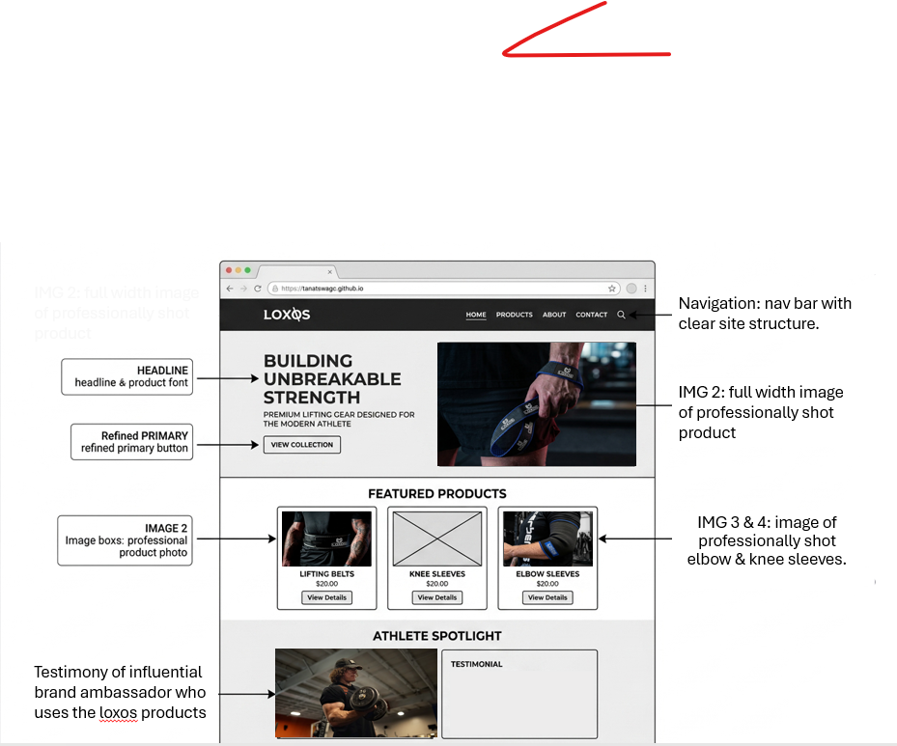

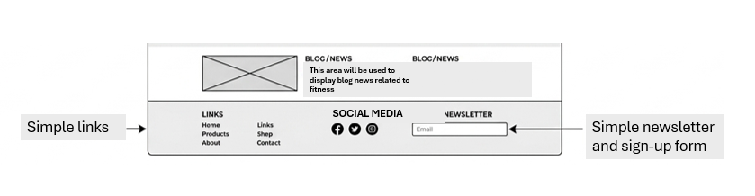
Home Page
1. The Home Page
The goal of the Home page is to establish the Loxos brand identity and guide users to the Shop as quickly as possible.
- Header Section: Contains the Loxos logo (top left) and a clean navigation menu (Home, Shop, Contact) .
- Hero Section: A high-impact visual area with a bold headline and a clear Call-to-Action (CTA) button labeled "View Collection." This is designed for the 16–30 age group who expect immediate direction.
- Featured Categories: Three grid-based blocks showing top-selling categories. This provides a "shortcut" for users who know exactly what they want.
- Trust Bar: A grey section featuring "Free Shipping" or "Secure Checkout" icons to build credibility with the 31–50 age group.

Shop Page

The Shop Page (The Functional Hub)
The Shop Page is designed with a modular grid system to ensure that high-performance gear—like elbow sleeves, figure 8 lifting straps, and lever belts,is presented with equal visual weight and clarity.
1. Product Grid Layout
The main body of the page is segmented into a responsive grid. Each product is housed within a "Product Card" that maintains the site's dark aesthetic:
- Visual Container: A dark grey (accent-grey) border with a subtle hover effect to indicate interactivity.
- Media Placeholder: A large area at the top of the card for high-quality product imagery.
- Quick Info: Directly below the image, the product title and price are displayed in bold white text for immediate recognition.
2. Navigation & "View Details" Logic
To keep the Shop Page clean and fast-loading, technical details are hidden from the main view.
- The "View Details" Button: Every product card features a prominent button. This acts as the primary gateway to the Product Detail Page (PDP).
- User Flow: When a user clicks "View Details," they are redirected to a dedicated page containing the full technical specifications, sizing charts, and material deep-dives.
- Consistency: This button uses the same CSS styling as the "Shop Now" button on the Home Page, reinforcing the user's "Technical Aptitude" by using familiar UI patterns.
3. Header & Filter Segmentation
- Breadcrumb Navigation: A small text trail (e.g., Home > Shop) appears below the main header, allowing users to navigate back easily without using the browser’s back button.
- Category Sorting: A horizontal bar allows users to filter the grid by category (e.g., "Supports," "Straps," "Belts"). This is essential for the 16–50 age demographic, ensuring they can find specific gear like the Lever Belts without scrolling through unrelated items.

Contact Page

The Contact Page: Global Footer & Engagement Zone
The lower segment of the Contact page serves as a comprehensive Engagement Zone. It is designed to capture user data via a newsletter and provide a "map" of the entire website.
1. Newsletter Integration (Lead Capture)
- The Interface: A minimalist input field designed for high contrast (white text on a dark blue background).
- Functionality: A single-field entry for emails with a "Subscribe" button. This is aimed at building long-term retention with the audience, allowing LOXØS to send updates on new gear directly to their inbox.
- Technical Logic: Includes real-time validation to ensure the entry follows a standard email@domain.com format, preventing accidental "empty" submissions.
2. Multi-Channel Navigation Grid
To ensure users never feel "stuck" at the bottom of the page, this section acts as a secondary navigation hub, segmented into three columns:
- Internal Links: Quick access to Home, Shop, Contact, and About. This provides a fallback for users who have scrolled past the main header.
- Social Connectivity: Direct links to LOXØS social media profiles. These are represented by recognizable icons, catering to the mobile-first habits of the 16–30 age group.
- Brand Pillars: A small "About" summary or a "Web Design by Tanatswa" credit to reinforce the brand's local and professional identity.
3. Dynamic Blog Placeholders (Content Discovery)
Even on the Contact page, we maintain user interest by including Blog Micro-Placeholders:
- Structure: Small, rectangular modules containing a thumbnail image and a short headline (e.g., "How to break in your new Lever Belt").
- Purpose: These placeholders entice users to stay on the site longer. By showing "coming soon" or actual blog snippets, you transition the user from a "task" (contacting you) back into "discovery" (learning about the products).

